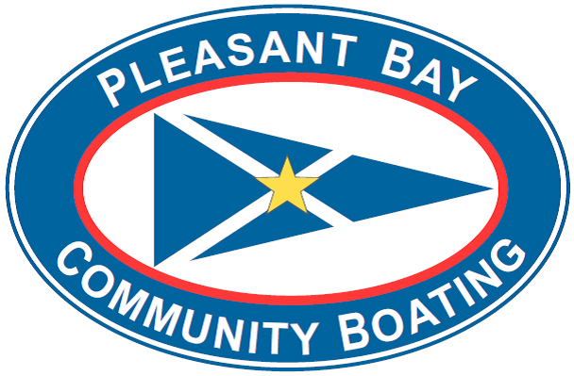

Financial Aid Application
Please complete this registration form and return with a letter from school, doctor, attorney, social services, etc. that verifies, without detail, your financial need.
Name: |  |  |  | Age:
Email:
Name of School: |  | Telephone:
Parent / Guardian:
Address:

Household Information:  Student Statement: | Members of Household:  Household Income: Less than $20,000  $20,000-$44,999 $45,000-$139,000  What program would you like to participate in and why? What dates would you like to participate?

Statement of need: | Parent / guardian should explain financial / other need for scholarship and how this opportunity will benefit your family: (Please use back side for additional space.)
The mission of Pleasant Bay Community Boating is to make boating, marine education, and environmental stewardship affordable and accessible to all. Our scholarship program is intended to assist area youth, who otherwise might be unable to afford regular program fees, to access our programs and beautiful Pleasant Bay.
Please email your application to fielda@pbcb.cc or mail to:
Pleasant Bay Community Boating // PO Box 21, North Chatham, MA 02650 // 508-945-7245 // www.pbcb.cc

